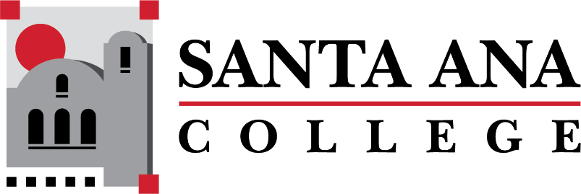

Dual Enrollment Workgroup Minutes
Tuesday, November 15, 2022 2:00-3:00pm., Hybrid
S-215 & Zoom

- Report out - Working Subgroups
  - Timelines – Merged SAUSD/SAC Schedule Production timeline has been created. Basti shared that timelines were discussed at a prior department chair meeting and three separate timeline considerations were discussed:
    - Schedule build timeline
    - Operational Timeline
    - Faculty Evaluation Timeline
      - A “timeline by role” suggestion was presented by Dr. Lamb to include Deans, Admin Secretaries, A&R, etc.
      - Samueli and GGUSD timelines are in the works.
  - Faculty Handbook – Claire Coyne, Ashly Bootman and Amberly Chamberlain have been working on items needed for a useful handbook and have come across the following:
    - Need for a Dynamic Dual Enrollment Resource Website/Dedicate one-stop information hub.
    - A DuE mission and vision statement
    - High School campus direct contacts
    - A concrete course request, selection and enrollment process
    - Hiring faculty process
    - Dedicated Dual Enrollment Counselors
    - Explanation of differences in Due faculty classifications: expectations, course outline of records.
    - Explanation of MOU and CCAP differences
      - Dr. Lamb recommended a list of questions be sent to the DuE group to have a focused meeting with key stakeholders to assist in answering those questions as a group.
      - Fresno City College site link was shared and provided a clean example of the look SAC is trying to achieve.
  - A&R – Batch enrollment is continuing along with Fall 2022 and audit cleanup. A&R is working alongside the DuE team for a cleaner process.
    - Dr. Nery asked A&R if a dedicated person for that work is needed – A&R said yes.
  - SAUSD Team – HS DuE workgroup is currently involving Counselors, Administrators, DSPS, Special Ed teachers and Student Support Systems to address deadlines, points of entry to increase access and equity – Not replace them.
- Canvas Report Out – Distance Education – Details shared regarding the colleague portal. Typically, the system can take up to 4 hours to provide students with canvas access once enrolled in a section. If there ever is an urgent addition needed, contact the Distance Ed Office.
  - New students automatically get enrolled in canvas training
  - Self-Service presentations being provided by SAUSD – Firewall issues are being investigated.
  - Online Teaching Certificate provides @1 training for free along with Flex Credit and CE Units
- Assessment Center – Maria Aguilar Beltran (streamlining waivers for student placement and assessment) - Placement process for English, Math and EMLS was discussed.
  - Dr. Nery recommended Registrar to Registrar to help with placement and process.
  - Summer “to-do” – Script creation to lift information and reduce manual work
- Bookstore Costs Discussion – Basti Lopez – Item was not discussed and will be moved to December meeting.
  - Spring 2023 Updates

Upcoming Meetings: December 6, 2022 | 2:00-3:00pm Hybrid
Save the Dates: DuE Retreats
- January 25, 2023 | 9:00am-12:00pm | JSC 219
- May 12, 2023 | 9:00am-12:00pm | JSC 219

